**“Radical to the Bone, Trouble Won’t Leave Me Alone” (Steel Pulse)**

**Radical Justice**: a critical reimagining of how systems and structures impact the outcomes of schools, educators, students, and community members. We strive toward radical justice by moving beyond “leveling the playing field” to disrupting and dismantling inequitable systems; we change the way the game is played.

*Radical Justice is one of the pillars of T.E.P because we believe in order for us to help end the miserable conditions that exist on this Earth we must think differently, we must allow ourselves the time and space to reimage an educational experience that works to emancipate the minds and bodies of the students and communities we serve. And in order for that liberation to be a possibility we must think radically about the current conditions and potential solutions.*

Let’s get started here:

[**The Trolley Problem**](https://www.youtube.com/watch?v=bOpf6KcWYyw)

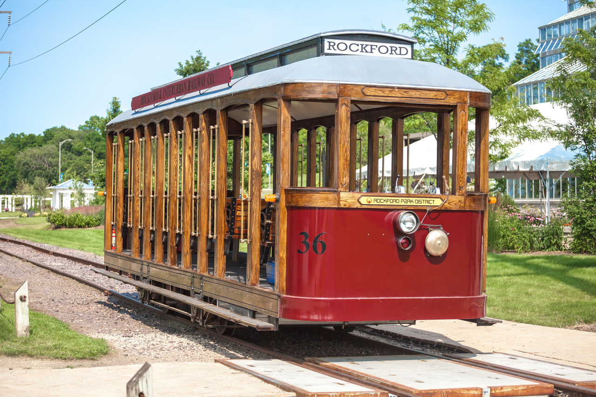

**Time to make your choice:**

Scenario 1 (Pulling the lever):

1. What is your choice? Why?

Yes, no one else is in a position to make this decision, and the preservation of life demands that the lever be pulled.

1. What are two of the questions you are asking yourself to help you make this decision?

Is this the better outcome and is it my choice to make?

Scenario 2 (Pushing the man):

1. What is your choice? Why?

No, if the man wants to save the five it is his choice to do so. He is in a position to make that decision and I will merely prompt him to do so.

1. What are two of the questions you are asking yourself to help you make this decision?

Is this the better outcome and is it my choice to make?

This situation is a difficult one because it is a zero-sum game regardless of the outcome that you choose. Either way, someone or someones are critically impacted based on the decision YOU make.

We **DO NOT** want you to think about education in these terms, that someone/s will have to sacrifice so much in order to save the many or the few. We **DO** want you to think about the choices you make as educators as heavy, and as worthy of consideration as questions like the “Trolley Problem”. Where we want to dare you to be different, and where Radical Justice dares you to be different, is we want you to also begin to consider the “Surreal” for solutions to the problems that you will face as an educator.

**YOUR 3rd Pillar Radical Justice:**

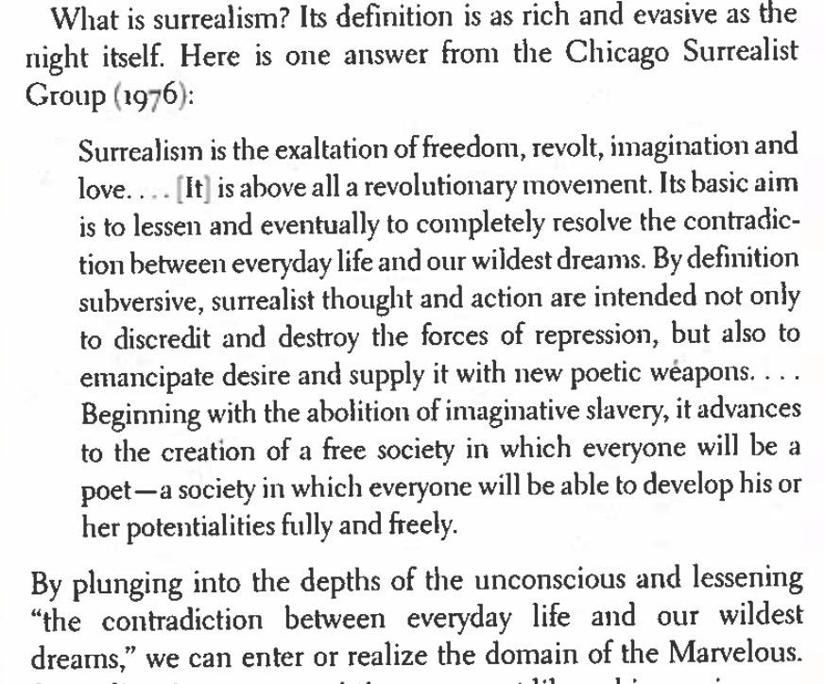

**(Freedom to Dream: Robin Kelly, 2022)**

**Find your own Partner:** The two (no more than 3) of you will continue to build on the work you have been doing on critical thinking and root cause analysis (RCA) on an issue in education. Complete this graphic organizer as a pair or small group and you will submit this graphic organizer in your 4690 canvas site.

**For your DOL:** You and your partner/group will have to create an artifact that demonstrates your surrealist thinking on the topic you all choose. Your artifact can be **ANYTHING** other than an essay, infographic, or slide show as long as it demonstrates your surrealism/radical justice thinking . You will be able to add your artifact to your DOL via: photos, videos, etc. Whatever it takes for us to be able to see the fruits of your labor. Great luck, and Life speed.

From your Critical Thinking/RCA, choose one of the potential solutions you developed and would like to continue to build on: Pay teachers more

Solution: Every school division should have the absolute power of eminent domain. This power should be controlled, not by elected school boards, but by a council of teachers and students elected from the schools themselves. This council can then seize land in the area to construct developments that serve the needs of education - affordable housing, community businesses and public services. The goal is for every aspect of a community to serve education, not just through a pittance in taxes

Answer the following about your potential solution, but answer as a surrealist. The sky's the limit, you have every resource you need to bring your solution to fruition you just have to provide the vision.

1. What are the **material** (physical, economic, spacial, etc.) conditions needed to bring your solution to life?

* Woof
* I mean, what wouldn’t we need?
* The big thing would be like, a fundamental political restructuring
* In terms of economics, it would basically be redirecting ground rent from capital accumulation to education funding, which I think would also have some positive effects

Why these and what are your expected outcomes?

1. What are the **social** (societal,communal,etc.) conditions needed to bring your solution to life?

* There would have to be a recognition of the social ownership of education
* A collective ownership that might include parents, but primarily concerns students and teachers
* It definitely doesn’t include randos though. Or homeschoolers.

Why these and what are your expected outcomes?

1. What forms of emancipation are to be gained from you being able to provide your solution?

* I think you would be able to address the actual needs of students while being shielded from the kinds of pressures that are often brought to bear to the detriment of students
* For instance, students and teachers aren’t the ones calling for Amazon-sponsored warehouse work classes - that’s all shitheads out there
* You would also have the ability, alongside parents, to dictate the material conditions of learning - something that would enable the kinds of learning students actually want